IN721 Mobile Development

**USB**

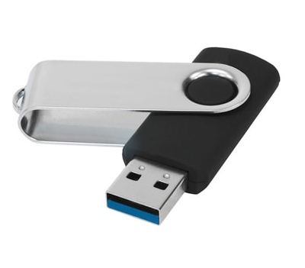

A USB is a device that people universally have trouble with. Everyone who has ever used a USB has tried to plug it in upside down.

The USB can be used for many things but they all have the same issue. The slot for the USB is rectangular but it only slots in one way, meaning there is a 50% chance when you try to plug it in you will be trying to plug it in the wrong way.

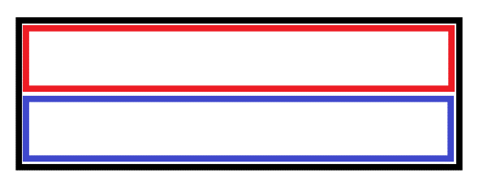The design on the device and the slot is not logical as it leads to people very commonly making the same mistake, regardless of technological literacy. A better design for the device would to be in any shape or form that isn’t symmetrical. An asymmetrical design would make it obvious which direction the device is supposed to be plugged in. Alternatively you could make the device receptive regardless of which way it is plugged in. e.g. below

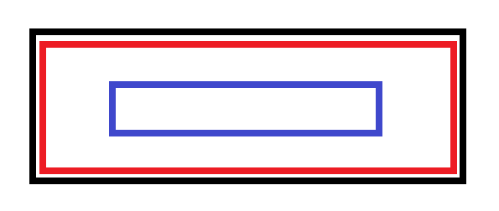

**New**

**Old**

Either solution would solve the difficulty and make the device easier to use for everyone.

Alternatively the device could clearly indicate which direction is the intended way to plug it in. This could easily be indicated on the device with some sort of icon or symbol denoting the correct way to plug it in. An indicator on the device and the slot that you line up would solve the problem and avoid the expensive issue of changing designs and legacy either being rendered useless or expensive maintained.